IBM Message Broker

Continuous Integration

V1.0

Author: R.Baines

Contents

Table of Contents

Introduction 3
The Tools 3
Plug-ins 3
Maven Installation 4
Installing the bespoke plug-ins 5
Getting Started 7
Build/Deployment Process Overview 8
Hudson’s Responsibilities 9
Maven’s Responsibilities 9
The Maven Process in Detail 9
01_PrepareEnv 9
02_BuildMessageFlows 10
maven-rsb-wmb-createbar 10
How a bar file is created 10
03_CopyToLatestBuild 11
The reason for doing this 12
04_DeployServices 12
maven-rsb-wmb-overridebar 12
maven-wmb-rsb-deploybar 13
Pom Structure 14
BrokerBuild 14
BrokerParent 14
01_PrepareEnv 18
02_BuildMessageFlows 18
Project Specific Directories 20
03_CopyToLatestBuild 20
04_DeployServices 21
Execution Group Specific Directories 21
Running build commands 23
clean 23
package 23
integration-test 23
fae 23
Running for a Profile 23
Adding new services to the build 24
Create directory for Project 24
Create pom.xml File 24
Add to BuildMessageFlows modules 25
Add to execution group pom.xml 25
Configuring a Hudson based Build Server 26
Prerequisites 26
Hudson Job Config 26
Troubleshooting 27

Introduction
This document is to describe the implementation of an automated build and deployment process using the open source tools Maven and Hudson.
This forms part of the move towards adopting “continuous integration” as a way of developing more robust and reliable applications and also helps to reduce the margin for error during build and deployment of the software artefacts.
The same build and deployment process can be used by both standalone developers, project teams and the EGG team.
By using the same process this should result in more reliable releases as the process should already have been tried and tested as part of the development process.

The Tools
Before starting you will need to download, install and configure a number of open source tools. The following document describes how to do this or references documentation on the web that covers this in detail.
Tools required are, Maven and Hudson.
Maven is an open source tool for scripting the build process.
Hudson is a open source tool for controlling the maven tasks from a web based user interface.
These two tools are commonly used in tandem to form a continuous integration solution.

Plug-ins
Maven is predominantly build to support java based developments however with the use of its extensible plug-in based architecture it is possible to craft your own extensions to Maven to support a diverse range of development platforms.
It is by developing our own plug-ins that we are able in incorporate the building and deployment of Message Broker artefacts into a Hudson/Maven based process.

Maven Installation
Download and install Maven 2.2.1 from the following URL http://maven.apache.org/download.html
As a default on windows it will be installed at the following location:-
C:\Program Files\Apache Software Foundation\apache-maven-2.2.1

Follow the installation instructions at the bottom of the downloads page:-
http://maven.apache.org/download.html#Installation
This describes which environment variables to set up to get your installation operational.

If it is correctly installed typing mvn –version should return something like the screen below:-
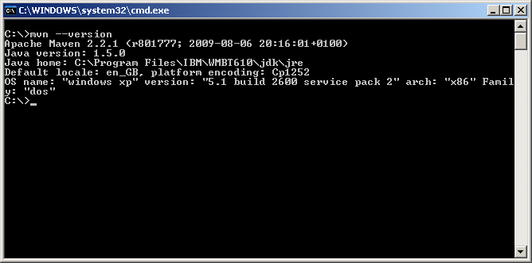
As you can see the JAVA_HOME variable is configured to use the java runtime environment used by the Message Broker Toolkit.
JAVA_HOME=C:\Program Files\IBM\WMBT610\jdk
If this is not already set you may need to do this as well.

Installing the bespoke plug-ins
In order to create message broker bar files, apply bar file overrides and deploy bar files to a broker you need to install 3 separate plug-ins that we have developed for xxx.
These are mini maven projects themselves so you just need to retrieve the appropriate source files and run the maven commands to compile and install the plug-ins.
The 3 plugins are:-
maven-rsb-wmb-createbar
maven-rsb-wmb-overridebar
maven-rsb-wmb-deploybar

Retrieve the source code for these projects from (insert location here)

Before the projects can be compiled some external jar files need to be added to the Maven local repository. These jar files are for communicating with IBM MQ, and the Message Broker Configuration Manager Proxy. They are only required for successful compilation of the “maven-rsb-wmb-deploybar” plug-in, they are not used by the other two plug-ins.

Start up a command line window and navigate to the directory containing the “maven-rsb-wmb-deploybar” project.

Type the following 3 commands to install the external jar files into the local Maven repository.
mvn install:install-file -Dfile=.\lib\com.ibm.mq.jar -DgroupId=com.ibm.mq -DartifactId=WebsphereMQClassesForJava -Dversion=6.0.2.2 -Dpackaging=jar
mvn install:install-file -Dfile=.\lib\connector.jar -DgroupId=javax.resource.cci -DartifactId=SunConnectorClasses -Dversion=1.3.0 -Dpackaging=jar
mvn install:install-file -Dfile=.\lib\ConfigManagerProxy.jar -DgroupId=com.ibm.broker.config -DartifactId=WMBConfigManagerProxy -Dversion=1.5.0 -Dpackaging=jar
Each command should be entered on a single line. (It is easier to copy the command text into notepad.exe first and edit there, then cut and paste to the command window if necessary).
If successful these 3 jar files should now be available in the maven local repository. The repository is normally located under the “.m2” directory under your current users “Documents and Settings”. The screenshot below shows the location that the Websphere MQ classes for Java have been copied to as a result of the earlier commands.
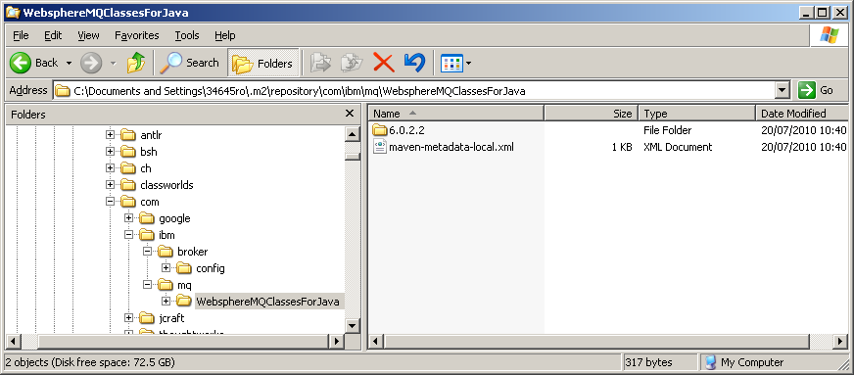

If all 3 jars have been installed you are ready to install the plugins.
In each of the project directories is a pom.xml file. So navigate to each directory in turn and type the following command:-
mvn install <enter>
Providing everything is correct you should see a screen similar to the one below, finishing with the comment BUILD SUCCESSFUL

The first time you run a maven install command you may download far more than shown above this is because maven will download an install and additional artefacts it needs from its online repository. We have added some additional jar files locally that are not available in it repository.
Once all 3 projects have been successfully built you are ready to start configuring an environment for local broker builds and deployments.

Getting Started
It is worth familiarising yourself with how Maven works generally. There is a raft of documentation available on the maven site and other associated sites.
http://maven.apache.org/index.html
A very good reference for Maven
http://www.sonatype.com/books/mvnref-book/reference/public-book.html

Build/Deployment Process Overview
The diagram below shows the build/deployment process.
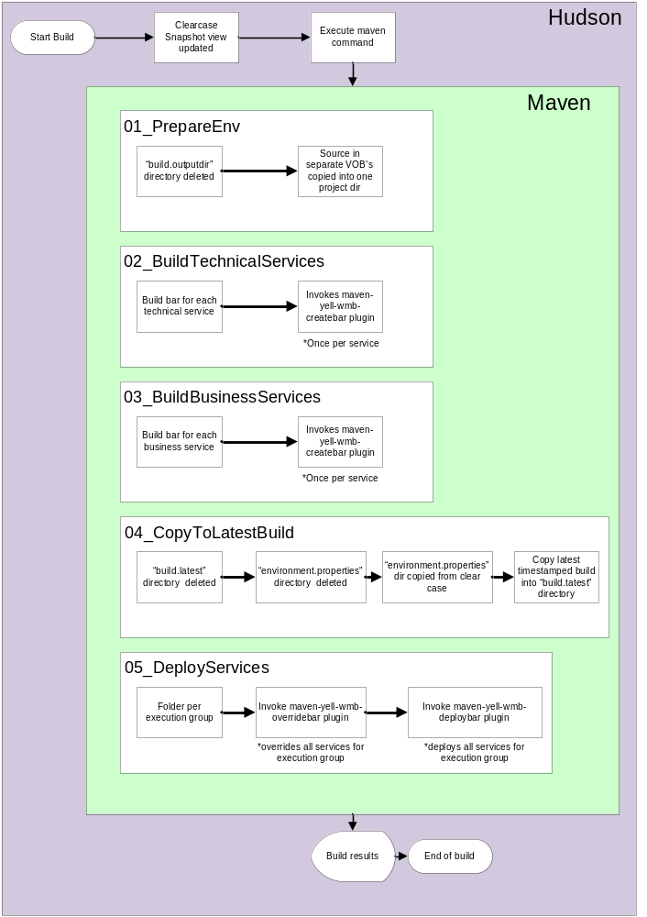
You can see there is a division between what Hudson does and what Maven does. The diagram is labelled to correspond with the relevant configuration sections in maven.

Hudson’s Responsibilities
The outer ring of the diagram shows that Hudson is the main controlling process of the build. For continuous integration this is essential. For developers performing local development where they need to compile and deploy their own code the outer Hudson layer may be replaced by their own manual actions in the development cycle.
When a build is invoked the first thing that Hudson will do is to update the clearcase snapshot view with the latest source code. (Details on configuring Hudson appear later in this document).
Once the snapshot view has been updated Hudson will invoke the maven command you have configured to run.
(See running build commands)

Without using Hudson a developer can run these same commands from a command prompt manually.

Maven’s Responsibilities
Maven will take care of the rest of the build and deployment process. In terms of Husdon invoking the process it will be configured to point to the pom.xml file at the top of the directory structure in the “BrokerParent” dir. Executing maven commands at this level will mean that the entire build process is executed. Maven will inspect all pom.xml files down the directory structure to compose a list of “modules” it must process.
From a developers perspective they may only be interested in creating a bar file for a single service. Therefore if they were located in the directory “MessageFlowProject1” and they executed the “mvn package” command they would only create a bar file for the one service. This makes maven a useful tool for developers in their own environment too. (Further detail of how a bar file is constructed later)

The Maven Process in Detail
Each section of the process is described here. The underlying configuration making this possible is described in the Pom Structure section.

01_PrepareEnv
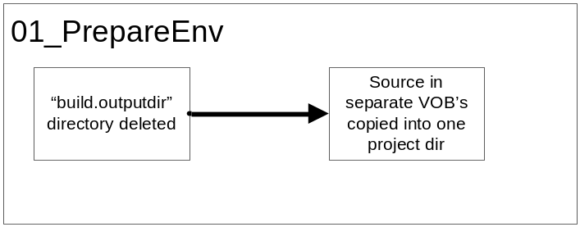
This process is responsible for preparing the build environment so that it is in a consistent state.
The directory configured in the “build.outputdir” is deleted and then source code from the following clearcase VOB’s is copied into a new version of the dir:-

Probably not applicable for other organisations

The reason all the VOB’s are copied into a single directory is so that the message broker toolkit can easily create a new workspace and import the relevant projects if they are located in a simple relative directory structure. As there are dependencies across all these VOB’s it is necessary.

02_BuildMessageFlows
This section of the process creates message broker bar (broker archive) files for each message flow project that is explicitly configured.
The 02_BuildMessageFlow pom.xml contains references to the “modules” it will build. Beneath this is a directory for each service that will be built, each containing a separate pom.xml for the service. This is so services can be explicitly configured.
By executing the “mvn package” command at this directory level would create bar files for all business services in one go.
The “maven-rsb-wmb-createbar” plugin is called once per service based upon the configuration of the pom.xml file in this directory.

maven-rsb-wmb-createbar
This plugin requires the following parameters:-
barFile – name of barfile to create
workspaceTarget – location of Eclipse workspace dir
wmbProject – name of project to build
mainArtifact – name of main controlling messageflow in project
mqsicreatebarLocation – location of mqsicreatebar command
verboseMode – if set to “true” it outputs additional detail to the log

How a bar file is created
The logic behind how a bar file is created is based upon the 2 main parameters required for the process.
- name of project
- name of “main artefact”

The project name relates to the directory that the .project file resides in for a message flow.
The “main artefact” is the name of the main controlling message flow, that contains the input node(s) to initiate the message flow. (Or in the case of xxx’s projects, the main flow which contains subflows with input nodes.) The main flow can be identified by the small green arrow in the toolkit showing that is it runnable.

These two parameters are passed to the maven-rsb-wmb-createbar plugin. What the plugin does is to inspect the .project file for any other project references. For each project reference found it checks those project too in a recursive fashion building up a list of dependent artefacts.
After processing all the .project files the plugin creates a list of projects and objects to pass to the mqsicreatebar command. Any artefact found with a suffix of .mset, .outadapter or .jar is included in the bar file. Artefacts with .msgflow are NOT included because if the message flows do not contain input nodes it causes the bar file creation to fail.
The net result is that you end up with a bar file that not only contains the message flow but it also contains ALL the required artefacts for a successful deployment. Eg. It will contain its message set, message sets of web services it calls, and adapter/message sets of SAP business functions it calls. This helps to greatly reduce deployment dependencies and also helps developers to locally deploy services very quickly for their own development and debugging purposes.
After the bar file has been created a second copy of the bar file is created with a suffix of “-withSource.bar”. This is created by unpacking the current bar file into a temporary working directory, then copying the source code from the related projects to a “src” directory and creating a brand new bar file.
This bar file “with source” is created for both successful and failed bar file creation. The benefit of having source code for failed creations is that a developer can create an empty workspace, import the sourcecode from the bar file and find out why the bar file failed to build.
As bar files are created in a timestamped directory we also end up with a copy of the source code at a specific point in time.
Failed creations have the tag [FAILED] incorporated in the file name for easy identification.
If a bar file fails to be created during to missing project source code a dummy bar file is created containing a text file with a description of why the bar file failed to be created. Eg. “Unable to find project xyz.”

03_CopyToLatestBuild
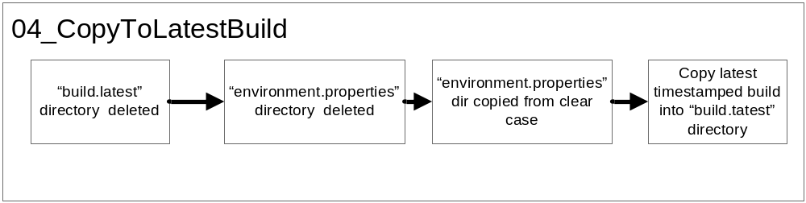
This section of the process is executed after the creation of all technical and business services. When a build is invoked all the bar files are generated in a time stamped directory.
As you can see below after a series of builds there are a number of directories with names in the yyyymmdd-hhMM format.
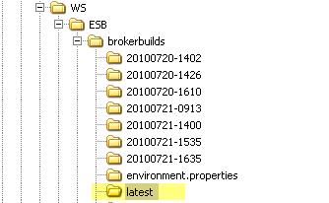
These directories can be retained as a point in time view of the artefacts being built.
However to simplify and also make the deployment part of the build rerunnable this additional step has been introduced into the process.
“03_CopyToLatestBuild” basically copies all the objects from the “current” time stamped build directory into a directory called “latest”.
First the “latest” directory is deleted, secondly the “environment.properties” directory is deleted. This is so there are no unwanted files from previous builds.
Next the “environment.properties” dir is copied from the xxx VOB of the clearcase view, to the “build.target” “environment.properties” dir. This is to retrieve the latest bar file override files from source control.
Finally the bar files from the time stamped build dir are copied into the “latest” dir.

The reason for doing this
The reason for doing this is that if the deployment process fails at any point it would result in a very lengthily rebuild of everything. When running a maven build there is a system provided property called “build.timestamp” which is used to determine where to place the generated bar files.
However if we rerun the build due to a failure at deployment time, we would need to regenerate ALL the bar files again (taking approximately 1 hour for just the echannel services). Using this approach providing all the steps up to and including 03_CopyToLatestBuild we can rerun stage 04_DeployServices independently as many times as we like.
This allows us to deploy the same generated bar files to different environments such as local developer, dev, test etc, without the need for complete regeneration.
To perform a quick deployment navigate to the “04_DeployServices” directory and run the “mvn integration-test” command.

04_DeployServices
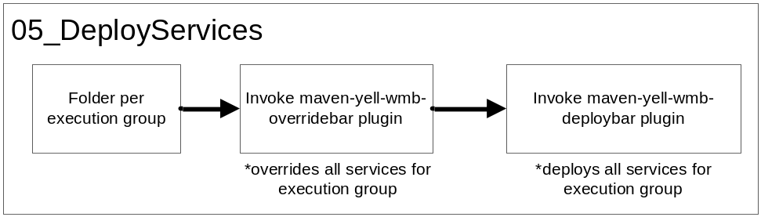
This section of the process is only executed if you run the “mvn integration-test” option of the build. This is for creating environment specific versions of the bar files and deploying to a particular message broker server.
The controlling pom.xml file has a reference to a number of modules, one per execution group.
Each execution group has its own dedicated directory. Within the directory is a pom.xml specifying which services are deployed to that particular execution group.
This section uses two separate plugin’s “maven-rsb-wmb-overridebar” and “maven-rsb-wmb-deploybar”

maven-rsb-wmb-overridebar
This plugin requires the following parameters:-
inputBarFiles – Array of bar file names
outputFileSuffix – string used as a suffix for output files (configured for environment.id)
overridesFile – name of bar file override file to apply
mqsiapplybaroverrideLocation – location of mqsiapplybaroverride command
This plugin receives a list of “input” bar file names to override for the particular execution group. It also expects to use a bar file override file named in the following format.
ExGrp_1_DEV_BAR_Overrides.properties
Execution group_Environment_Suffix
The filename is automatically constructed for use in the main pom.xml of the build. This file naming standard is already being used by the EGG team.
This is the line in the pom.xml that defines the parameter value:-
<overridesFile>${build.target}${env.FileSep}environment.properties${env.FileSep}${artifactId}_${env.id}_BAR_Overrides.properties</overridesFile>
The plugin applies the bar file override to all the input bar files and creates an output bar file with the environment id in the output file name.
Eg. Bar file:-
MessageFlowProject.01.00.bar becomes
MessageFlowProject.01.00_DEV.bar

The plug will process ALL bar files passed to it before existing. If any fail to be overridden it will still continue to the end.

maven-wmb-rsb-deploybar
This plugin requires the following parameters:-
barFiles – Array of bar file names to deploy
hostname – hostname of server containing queue manager to deploy to
port – port that queue manager is listening on
queueManager – name of queue manager
brokerName – name of broker to deploy to
executionGroup – name of execution group to deploy to
clearBeforeDeploy – “true” will delete any existing artefacts before deployment(only applies to first thing deployed.) Allows for a complete clear down of group as part of the deployment.
deploymentTimeout – time in milliseconds that deployment command will wait for a response from config manager proxy

The plugin tries to deploy all the bar files passed in the barflies parameter. If a bar file fails to deploy it will continue only reporting a failure at the end of all bar files.
You must make sure that the user who is running the Hudson/maven process has the correct access rights to the configuration manager proxy. This is done by running the mqsicreateaclentry -u <username> -a -x F -p -n <configfile.configmgr> command.
The “configfile.configmgr” file can be a connection file you have created using the broker toolkit.
Note:- during testing I was unable to add an acl entry locally due to the command not correctly authenticating a domain user. Only by running the command from a remote pc (as the same user!) I was able to execute the command. This is due to a bug in authenticating a user on a domain.

Pom Structure
The diagram below shows the overall structure of the broker directories for the maven build/deploy.

The directory structure and associated pom.xml files is explained in further detailed below.

BrokerBuild
This is an empty directory only containing the BrokerParent directory.

BrokerParent
This is contains the main pom.xml file. Many of the default parameters for the build are configured here. Pom.xml files lower down the directory tree will read backwards up the tree to retrieve the correct configured values.
<project xmlns="http://maven.apache.org/POM/4.0.0"
xmlns:xsi="http://www.w3.org/2001/XMLSchema-instance"
xsi:schemaLocation="http://maven.apache.org/POM/4.0.0 http://maven.apache.org/maven-v4_0_0.xsd">

<modelVersion>4.0.0</modelVersion>
<groupId>com.rsb.broker</groupId>
<version>1.0.0</version>
<artifactId>BrokerParent</artifactId>
<packaging>pom</packaging>
<name>rsb Broker Project</name>
<modules>
<module>01_PrepareEnv</module>
<module>02_BuildMessageFlows</module>
<module>03_CopyToLatestBuild</module>
<module>04_DeployServices</module>
</modules>

These modules specify the sequence the build runs in.

<properties>
<maven.build.timestamp.format>
yyyyMMdd-HHmm</maven.build.timestamp.format>
</properties>
<build>
<pluginManagement>
<plugins>
<plugin>
<groupId>org.apache.maven.plugins</groupId>
<artifactId>maven-jar-plugin</artifactId>
<version>2.2</version>
<inherited>false</inherited>
</plugin>
<plugin>
<groupId>org.apache.maven.plugins</groupId>
<artifactId>maven-scm-plugin</artifactId>
<version>1.3</version>
</plugin>
<plugin>
<groupId>org.apache.maven.plugins</groupId>
<artifactId>maven-surefire-plugin</artifactId>
<version>2.5</version>
</plugin>
<plugin>
<groupId>org.apache.maven.plugins</groupId>
<artifactId>maven-clean-plugin</artifactId>
<version>2.4.1</version>
</plugin>
<plugin>
<groupId>com.rsb.broker</groupId>
<artifactId>maven-rsb-wmb-createbar</artifactId>
<executions>
<execution>
<id>createbar</id>
<phase>package</phase>
<goals>
<goal>createbar</goal>
</goals>
</execution>
</executions>
<configuration>
<workspaceTarget>
${build.outputdir}
</workspaceTarget>
<mqsicreatebarLocation>${mqsicreatebarLocation}</mqsicreatebarLocation>
<verboseMode>false</verboseMode>
</configuration>
</plugin>
<plugin>
<groupId>com.rsb.broker</groupId>
<artifactId>maven-rsb-wmb-overridebar</artifactId>
<executions>
<execution>
<id>overridebar</id>
<phase>integration-test</phase>
<goals>
<goal>overridebar</goal>
</goals>
</execution>
</executions>
<configuration>
<outputFileSuffix>_${env.id}</outputFileSuffix>
<mqsiapplybaroverrideLocation>${mqsiapplybaroverrideLocation}</mqsiapplybaroverrideLocation>
<overridesFile>${build.target}${env.FileSep}environment.properties${env.FileSep}${artifactId}_${env.id}_BAR_Overrides.properties</overridesFile>
</configuration>
</plugin>
<plugin>
<groupId>com.rsb.broker</groupId>
<artifactId>maven-rsb-wmb-deploybar</artifactId>
<executions>
<execution>
<id>deploybar</id>
<phase>integration-test</phase>
<goals>
<goal>deploybar</goal>
</goals>
</execution>
</executions>
<configuration>
<workspaceTarget>
${build.outputdir}
</workspaceTarget>
<hostname>${hostname}</hostname>
<port>${port}</port>
<queueManager>${queueManager}</queueManager>
<brokerName>${brokerName}</brokerName>
</configuration>
</plugin>
</plugins>
</pluginManagement>
</build>
The environment specific properties are the part that is likely to change the most.
This file contains 2 “profiles”, the “local” profile is targeted at a developer working on his/her own machine. The “xxxBroker” is configured to compile and build on one machine and deploy to a separate machine. Further profiles can be easily configured.

<!-- #################################### -->
<!-- Environment specific profiles -->
<!-- #################################### -->
<profiles>
<profile>
<!-- ################################################################################ -->
<!-- This is the default "local" profile user by developers on an windows environment -->
<!-- ################################################################################ -->
<id>local</id>
<activation>
<activeByDefault>true</activeByDefault>
This defines this as the default build profile if no profile is specified.
</activation>
<properties>
<!-- id for build, used in filenames for bar file overrides -->
<env.id>DEV</env.id>
Environment id is used to determine which bar file override files to apply.
<env.FileSep>\</env.FileSep>
The file separator is soft coded so the same maven config files can be used on unix and windows environments.
<!-- location of clearcase view where all VOB's reside -->
<clearcase.view.location>C:\ClearCase\wmb_view</clearcase.view.location>
This is the location of the clearcase view to retrieve source code from.
<!-- Eclipse workspace for build, this dir will be deleted during each build -->
<build.outputdir>C:\WS\wmb\mavenworkspace</build.outputdir>
<!-- directory where builds are created, a new dir named by timestamp will be added each build -->
<build.target>C:\WS\wmb\brokerbuilds</build.target>
<!-- once all bar files are created they are copied to the dir specified below -->
<build.latest>C:\WS\wmb\brokerbuilds\latest</build.latest>
<!-- details for config manager/broker to deploy to -->
<hostname>localhost</hostname>
<port>2414</port>
<queueManager>WBRK61_DEFAULT_QUEUE_MANAGER</queueManager>
<brokerName>WBRK61_DEFAULT_BROKER</brokerName>
<!-- location of wmb toolkit commands -->
<mqsicreatebarLocation>C:\Program Files\IBM\WMBT610\mqsicreatebar</mqsicreatebarLocation>
<mqsiapplybaroverrideLocation>C:\Program Files\IBM\WMBT610\mqsiapplybaroverride</mqsiapplybaroverrideLocation>
</properties>
</profile>
<profile>
<!-- ################################################################################ -->
<!-- This is the profile to deploy to the xxxBroker on an windows environment -->
<!-- ################################################################################ -->
<id>xxxBroker</id>
<properties>
<!-- id for build, used in filenames for bar file overrides -->
<env.id>DEV</env.id>
<env.FileSep>\</env.FileSep>
<!-- location of clearcase view where all VOB's reside -->
<clearcase.view.location>C:\Documents and Settings\xxx\.hudson\jobs\wmb\workspace\wmb_Hudson</clearcase.view.location>
<!-- Eclipse workspace for build, this dir will be deleted during each build -->
<build.outputdir>C:\WS\ESB</build.outputdir>
<!-- directory where builds are created, a new dir named by timestamp will be added each build -->
<build.target>C:\WS\builds</build.target>
<!-- once all bar files are created they are copied to the dir specified below -->
<build.latest>C:\WS\builds\latest</build.latest>
<!-- details for config manager/broker to deploy to -->
<hostname>yeps57113</hostname>
<port>1416</port>
<queueManager>labsQM</queueManager>
<brokerName>labsBroker</brokerName>
<!-- location of wmb toolkit commands -->
<mqsicreatebarLocation>C:\Program Files\IBM\WMBT610\mqsicreatebar</mqsicreatebarLocation>
<mqsiapplybaroverrideLocation>C:\Program Files\IBM\WMBT610\mqsiapplybaroverride</mqsiapplybaroverrideLocation>
</properties>
</profile>
<!--<clearcase.view.location>
C:\Documents and Settings\36096Us\.hudson\jobs\eChannel ESB\workspace\esb_Hudson
</clearcase.view.location> -->

</profiles>
</project>

01_PrepareEnv
This pom.xml is unlikely to change much unless there are new VOB’s added to the clearcase branches.
<project>
<modelVersion>4.0.0</modelVersion>
<parent>
<groupId>com.rsb.broker</groupId>
<version>1.0.0</version>
<artifactId>BrokerParent</artifactId>
</parent>
<artifactId>01_PrepareEnv</artifactId>
<version>01.00</version>
<name>01_PrepareEnv</name>
<build>
<plugins>
<plugin>
<artifactId>maven-antrun-plugin</artifactId>
<executions>
<execution>
<phase>validate</phase>
<configuration>
<tasks>
<delete dir="${build.outputdir}" />
</tasks>
</configuration>
<goals>
<goal>run</goal>
</goals>
</execution>
</executions>
</plugin>
<plugin>
<artifactId>maven-resources-plugin</artifactId>
<version>2.4.3</version>
<executions>
<execution>
<id>copy-resources</id>

<phase>validate</phase>
<goals>
<goal>copy-resources</goal>
</goals>
<configuration>
<!-- used to flatten directories split but stupid VOB setup in clearcase! -->
<outputDirectory>${build.outputdir}</outputDirectory>
<resources>
<resource>
<directory>${clearcase.view.location}${env.FileSep}vob dir</directory>
<filtering>false</filtering>
</resource>
</resources>
</configuration>
</execution>
</executions>
</plugin>
</plugins>
</build>
</project>

02_BuildMessageFlows
This pom.xml will need new module entries for each message flow projec and a new supporting directory for each project.
<project>
<modelVersion>4.0.0</modelVersion>
<parent>
<groupId>com.rsb.broker</groupId>
<version>1.0.0</version>
<artifactId>BrokerParent</artifactId>

</parent>
<artifactId>02_BuildMessageFlows</artifactId>
<version>01.00</version>
<name>02_BuildMessageFlows</name>
<packaging>pom</packaging>
<!-- add a module name here for each service to build-->
<!-- each service with have its own directory with its own pom.xml -->
<modules>
<module>MessageFlowProject1</module>
<module>MessageFlowProject2</module>
</modules>
</project>

Project Specific Directories
There is one directory per project.
This is an example pom.xml for the MessageFlowProject1 service. Parts highlighted in yellow would need changing for each new service.
<project>
<modelVersion>4.0.0</modelVersion>
<parent>
<groupId>com.rsb.broker</groupId>
<version>01.00</version>
<artifactId>02_BuildMessageFlows</artifactId>
</parent>
<artifactId>MessageFlowProject1</artifactId>
<version>01.00</version>
<name>MessageFlowProject1</name>
<build>
<plugins>
<plugin>
<groupId>com.rsb.broker</groupId>
<artifactId>maven-rsb-wmb-createbar</artifactId>
<extensions>true</extensions>
<configuration>
<barfile>${build.target}${env.FileSep}${build.timestamp}${env.FileSep}${project.artifactId}.${version}.bar</barfile>
<wmbProject>
${project.artifactId}
</wmbProject>
<mainArtifact>
${project.artifactId}${env.FileSep}MessageFlowProject1${env.FileSep}MessageFlowProject1.msgflow
</mainArtifact>
</configuration>
</plugin>
</plugins>
</build>
</project>

03_CopyToLatestBuild
This pom.xml should not require amendment.
<project>
<modelVersion>4.0.0</modelVersion>
<parent>
<groupId>com.rsb.broker</groupId>
<version>1.0.0</version>
<artifactId>BrokerParent</artifactId>
</parent>
<artifactId>03_CopyToLatestBuild</artifactId>
<version>01.00</version>
<name>03_CopyToLatestBuild</name>
<build>
<plugins>
<plugin>
<artifactId>maven-antrun-plugin</artifactId>
<executions>
<execution>
<phase>validate</phase>
<configuration>
<tasks>
<delete dir="${build.latest}" />
<delete dir="${build.target}${env.FileSep}environment.properties" />
</tasks>
</configuration>
<goals>
<goal>run</goal>
</goals>
</execution>
</executions>
</plugin>
<plugin>
<artifactId>maven-resources-plugin</artifactId>
<version>2.4.3</version>
<executions>
<execution>
<id>copy-resources</id>
<goals>
<goal>copy-resources</goal>
</goals>
<phase>validate</phase>
<configuration>
<!-- copies latest build from timestamped dir to "latestbuild" dir for deployment -->
<outputDirectory>${build.target}${env.FileSep}environment.properties</outputDirectory>
<resources>
<resource>
<directory>${clearcase.view.location}${env.FileSep}BladeLogic${env.FileSep}environment.properties</directory>
<filtering>false</filtering>
</resource>
</resources>
</configuration>
</execution>
<execution>
<id>copy-resources2</id>
<goals>
<goal>copy-resources</goal>
</goals>
<phase>validate</phase>
<configuration>
<!-- copies latest build from timestamped dir to "latestbuild" dir for deployment -->
<outputDirectory>${build.latest}</outputDirectory>
<resources>
<resource>
<directory>${build.target}${env.FileSep}${build.timestamp}</directory>
<filtering>false</filtering>
</resource>
</resources>
</configuration>
</execution>
</executions>
</plugin>
</plugins>
</build>
</project>

04_DeployServices
This pom.xml contains one module reference per execution group.
It will need modifying to incorporate new execution groups.
<project>
<modelVersion>4.0.0</modelVersion>
<parent>
<groupId>com.rsb.broker</groupId>
<version>1.0.0</version>
<artifactId>BrokerParent</artifactId>
</parent>
<artifactId>05_DeployServices</artifactId>
<version>01.00</version>
<name>05_DeployServices</name>
<packaging>pom</packaging>
<!-- add a module names here for execution groups to deploy to-->
<!-- each execution group will have its own directory with its own pom.xml -->
<modules>
<module>ExGrp_1</module>
<module>ExGrp_2</module>
</modules>
</project>

Execution Group Specific Directories
This pom.xml contains all the details of the bar files to override and deploy. This is the only part of the configuration that is tricky. Firstly because you need to enter the correct version numbers on the end of the bar files. (These can easily be found by inspecting the latest build folder after a trial build). Secondly the bar file names need to be duplicated between the overridebar plugin and the deploybar plugin. Note that the deploybar plugin names also have the env.id embedded in them. Eg. “DEV”
<project>
<modelVersion>4.0.0</modelVersion>
<parent>
<groupId>com.rsb.broker</groupId>
<version>01.00</version>
<artifactId>04_DeployServices</artifactId>
</parent>
<artifactId>ExGrp_1</artifactId>
<version>01.00</version>
<name>ExGrp_1</name>
<packaging>pom</packaging>
<build>
<plugins>
<plugin>
<groupId>com.rsb.broker</groupId>
<artifactId>maven-rsb-wmb-overridebar</artifactId>
<extensions>true</extensions>
<configuration>
<!-- add a list of barfiles to override here -->
<inputBarfiles>
<param>${build.latest}${env.FileSep}MessageFlowProject1.01.00.bar</param>
<param>${build.latest}${env.FileSep}MesageFlowProject1_V01.00.01.00.bar</param>
</inputBarfiles>
</configuration>
</plugin>
<plugin>
<groupId>com.rsb.broker</groupId>
<artifactId>maven-rsb-wmb-deploybar</artifactId>
<extensions>true</extensions>
<configuration>
<!-- add a list of barfiles to deploy here -->
<barfiles>
<param>${build.latest}${env.FileSep}MessageFlow2.01.00_${env.id}.bar</param>
<param>${build.latest}${env.FileSep}MessageFlow2_V01.00.01.00_${env.id}.bar</param>
</barfiles>
<executionGroup>${artifactId}</executionGroup>
<clearBeforeDeploy>true</clearBeforeDeploy>
<deploymentTimeout>600000</deploymentTimeout>
</configuration>
</plugin>
</plugins>
</build>
</project>

Running build commands
There are two possible maven commands that can be run with the current configuration.

mvm clean package –fae
or
mvm clean integration-test –fae

clean
Running clean will simply delete all the “target” directories generated by the build.

package
The “package” option will to a complete build of all the broker artefacts but will not deploy them. At the end of a successful build there should be a complete set of bar files. In a timestamped build directory and also copied into the directory configured in the “build.latest” directory.

integration-test
The “integration-test” option will perform exactly the same actions are the package option but afterwards will create a set of bar files overridden for a specific environment (eg DEV) and they deploy the overridden bar files to a broker.

fae
Using the –fae option means “fail at end” which allows you to run an entire build without stopping for failed projects. This is much more efficient when you want to discover every failed project in one go.

Running for a Profile
mvm clean integration-test –fae –P <profile>
This final option of –P <profile> allows you to run a build for a specific profile. If –P is not included the build will run for the default profile (currently the developers profile). In the examples in this document there is also a profile called “xxxBroker” which is used to deploy to a separate windows machine running message broker.
Profiles can be set up for all the environments you wish to deploy to.

Adding new services to the build
The “POM Structure” section of the document describes how the pom.xml files are organised. This is a set of simple steps required if you are adding new message flow projects to the build.
- Create directory for message flow project
- Create pom.xml File
- Add to project modules
- Add to execution group pom.xml

Create directory for Project
Each project requires its own dedicated directory in the directory tree. Add a new directory that reflects the name of the project. This belongs beneath the “02_BuildMessageFlows” directory.

Create pom.xml File
Within the new directory create a pom.xml file for the service. This can be based upon one of the existing pom.xml files.
Amend the highlighted sections with details relevant to the service.
<project>
<modelVersion>4.0.0</modelVersion>
<parent>
<groupId>com.rsb.broker</groupId>
<version>01.00</version>
<artifactId>02_BuildMessageFlows</artifactId>
</parent>
<artifactId>MessageFlowProject1</artifactId>
<version>01.00</version>
<name>MessageFlowProject1</name>
<build>
<plugins>
<plugin>
<groupId>com.rsb.broker</groupId>
<artifactId>maven-rsb-wmb-createbar</artifactId>
<extensions>true</extensions>
<configuration>
<barfile>${build.target}${env.FileSep}${build.timestamp}${env.FileSep}${project.artifactId}.${version}.bar</barfile>
<wmbProject>
${project.artifactId}
</wmbProject>
<mainArtifact>
${project.artifactId}${env.FileSep}MesageFlowProject1${env.FileSep}MessageFlowProject1.msgflow
</mainArtifact>
</configuration>
</plugin>
</plugins>
</build>
</project>
Make sure the version is accurate because this is appended to the name of the barfile being created.

Add to BuildMessageFlows modules
To make sure the new service is included in the build add a new entry in the modules section of the “02_BuildMessageFlows” pom.xml
<modules>
<module>MessageFlowProject1</module>
<module>MessageFlowProject2</module>
</modules>

When running the mvn command you will quickly see if the module has been included or not.

Add to execution group pom.xml
If you are also planning on automatically deploying your service you must also add its details to the pom.xml file for the corresponding execution group.
If you are creating configuration for a brand new execution group you will also need to create a dedicated directory for the execution group beneath the “04_DeployServices” dir. Not forgetting to add a module reference to the new directory

Configuring a Hudson based Build Server
Install Hudson.
Installation of WMB Toolkit 6.1.0.5
Copy C:\SAP\* dir to machine for building SAP adapters. (Not sure about a linux based build machine…)
Setup clearcase view
Create Hudson “job” for building

Prerequisites
To enable Hudson to successfully run the maven build a number of prerequisites were required.
- Install Message Broker Toolkit version 6.1.0.5
- Install SAP adapter libraries in C:\SAP (detailed in SAP adapter docs on portal)

Hudson Job Config

Config spec for source retrieval.

The Root POM points to the BrokerParent\pom.xml file which is the main controlling pom for the maven build.
At time of writing this was not held within clearcase so the BrokerParent directory was manually copied to a location in the esb_Hudson workspace.
This should be set up within clearcase so that pom.xml and all child directories are retrieved from clear case.

TODO
The default MAVEN_OPTS were amended to increase the amount of RAM allocated to the build process. Also an option of preventing the process from forking was added as builds were failing with a “process nnnnnnnn killed” message.

Troubleshooting
Maven does not show any failure messages when trying to copy resources. So if you receive a “.project not found” error message it is worth checking that the clearcase view is set up correctly and is being copied into your Hudson workspace as expected.

